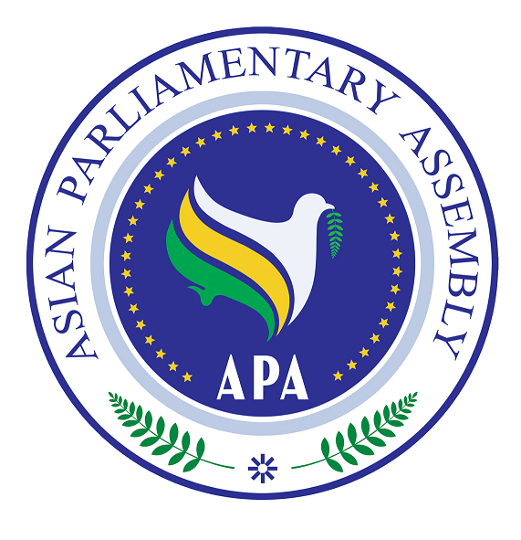
Asian Parliamentary Assembly

SG/Rep/2010/13
22 June, 2010

The Report
of the APA Secretary-General

on

Protecting and Respecting Cultural Diversity in Asia

Phnom Penh- Cambodia
5-6 July, 2010

Background

In 2006 APA Plenary decided to establish a working group to prepare a Plan of Action for Protecting and Respecting Cultural Diversity in Asia. In 2007, when this Plan of Action was discussed by the APA Executive Council and certain modifications were made, the Plenary adopted the text of the Plan of Action by passing the Resolution APA/Res/2007/02.

In that Resolution, the APA Plenary decided to establish a sub-committee under the Cultural and Social Committee to consider the best ways and means to facilitate the implementation of provisions of the Plan of Action on Cultural Diversity in Asia. The Sub-Committee on Protecting and Respecting Cultural Diversity held its first meeting on 21-22 October 2008 in Seoul, and the second meeting on 27 June 2009 in Tehran, the Islamic republic of Iran.

Based on the deliberations of its meetings, the Sub-Committee recommended a draft resolution to the first meeting of the Executive Council in 2009, which was later adopted by the APA Plenary as its resolution APA/Res/2009/05, dated 10 December 2009.

Priorities

The APA Plenary in its Resolution on Protecting and Respecting Cultural Diversity in Asia (APA/Res/2009/05, dated 10 December 2009) underlines the significant role of parliaments both in strengthening national cultural policies and in harmonizing Asian approach for protecting and respecting cultural diversity. It emphasizes that cultural diversity provides the ground for constructive interactions among different cultures and allows mutual enrichment and thus encourages relevant government agencies to increase facilitation for greater people-to-people interactions. It also requested the Secretary General to continue its sponsorship for an award to be presented annually to an Asian artist; author, poet, film maker, painter, etc, who best conveys the APA message of Asian cooperation and integration;

APA Plan of Action on protecting and respecting cultural diversity embraces a wide range of measures to be taken by each Member Parliament individually and by the APA collectively. To prioritize the Sub-committee’s activity in Cambodia, the Secretary General wishes to focus on the two significant issues: A- Common Legislation, B- Dialogue and Understanding among Cultures and Religions

A- Common Legislation

Embracing the most ancient civilizations of the world, Asia is in dire need to preserve and protect its collective cultural heritage. The smuggling of cultural objects is a plague that damages the cultural integrity of Asia. To combat such anti-cultural phenomenon requires close cooperation among all Asian countries. Transparent laws and regulations for protecting cultural items constitute a basic and important aspect of this campaign. As an Assembly of law-making and legislative body, the APA is in a proper position to take certain steps in order to remove legal loopholes in trafficking cultural items across the Asia. A practical and effective measure towards this goal would require the adoption of a model-legislation on combating the smuggling of cultural items.

The Secretary General wishes to underline the importance of the three international conventions on combating illicit trafficking of cultural objects as a proper ground for global and regional cooperation. Those conventions are as follow:
- Convention on the Means of Prohibiting and Preventing the Illicit, Export and Transfer of Ownership of Cultural Property 1970, which was adopted by the General Conference of UNESCO and entered into force on 24 April 1972,
- UNIDROIT Convention on Stolen or Illegally Exported Cultural Objects (Rome, 24 June 1955),
- International Convention on Mutual Administrative Assistance for the Prevention, Investigation and Repression of Customs Offences.
In addition to these international conventions, there are several bilateral agreements and regional conventions particularly among European and American countries for protecting their cultural heritage. It is imperative for APA to take practical steps toward a unified position and a coordinated policy and action through initiating a concerted legislation for combating illicit trafficking of cultural objects in Asia.

Operative 2 of the Resolution (APA/Res/2009/05, dated 10 December 2009) expressed the APA resolve to develop and promote adoption of concerted legislation among Member Parliaments to combat smuggling of cultural items in Asia, and in this respect, decided to establish an ad-hoc group with at least three member parliaments to prepare a draft common legislation, and request the Secretary-General to share these findings with all members for final coordination and consideration.
Based on the above-mentioned conventions, The Secretary General is of the view that legal exchange of cultural items for cultural and educational purposes enhances public awareness and mutual respect of nations. At the same time illegal trade, theft and smuggling of cultural items causes irreparable damages to the cultural heritage of Asian nations. Thus it is imperative for APA to develop and reinforce combat against smuggling of cultural properties through concerted legislations, and harmonizing an Asian approach. Such legislations would establish, modify and strengthen national legal systems; and enhance regional cooperation among Asian countries to fight smuggling of cultural items, with due regard to the following principles;
1. Lawful exchange of cultural and historical properties enriches cultural and social existence of nations; strengthens mutual respect and leads to amity and friendship among them,
2. Movable cultural heritage of every nation is considered as fundamental elements of culture and civilization of that nation, and an integral part of regional and human culture and civilization and thus necessitates regional cooperation to fight theft and smuggling of cultural properties,
3. Protection and safeguarding of historical cultural properties from the perils of unlawful excavations, theft and smuggling, is inter alia the duty of the governments,
4. Clandestine excavations in archeological sites, theft, illicit import and export of cultural properties constitutes as one of the main reasons for the cultural impoverishment of the countries of the origin of these objects.
5. Establishment and strengthening of a proper system of management to protect immovable cultural heritage and reinforce coordination and cooperation among concerned institutions for combating theft and smuggling of cultural properties,
6. Documentation, preparation and completion of an inventory of national cultural properties,
7. Proper supervision over archeological excavations, standardization of the means to protect cultural items at the site of discovery,
8. Taking educational steps to enhance public awareness on the necessity of protecting cultural objects,
9. Encouraging and developing the educational, scientific and technical institutions required for protecting cultural items; expanding museums; supporting cooperation and exchanging cultural objects among museums in Asian countries,
10. Issuing special permit for those cultural objects the export of which is authorized; and thwarting illicit import and export of cultural items with no permit, and restitution thereof to the country of origin,
11. Promoting international cooperation to combat smuggling of cultural items with the countries of origin on restitution of cultural properties as well as extradition of those charged with theft and smuggling of cultural items,
12. Stress on the inalienable right of every country concerning classification and declaring as non-transferable certain cultural properties and preventing entry into the national territory of those items.

If the Sub-Committee regards these principles as the underlying rules for promotion and protection of Asian cultural heritage, the APA would take a step forward for a common legislation on combating illicit trafficking of cultural objects in Asia.

B-Dialogue and Understanding among Cultures and Religions

Asia has been the cradle of the great religions, ancient civilizations and rich cultures; dialogue and understanding among such cultures and religions will promote Asian common values and enhance cooperation, peace and friendship while diminishing the risks of discrimination, violence, and war. To identify essential values inherent in the world’s major religions and ethical traditions would provide guidance to further promotion of peace, human security and sustainable environment.
To achieve this significant objective Operative paragraph 8 of the Resolution on Protecting and Respecting Cultural Diversity in Asia (APA/Res/ 2009/ 05) recommends Parliaments and governments of Asian countries to promote dialogue and understanding among cultures and religions in order to foster integration, peace and friendship in Asia.

The Center for Interreligious Dialogue (CID) after extensive consultation with the Secretary General has expressed its readiness to take practical steps toward the implementation of this goal. Among the main objectives of the Center for Interreligious Dialogue are to create a platform for fostering mutual understanding between the followers of different religions and to remove existing mistrusts and misunderstandings. It also seeks the cooperation of the thinkers of different religious tradition and promotes solidarity among the leaders and the followers of divine religions with a view to encountering the spiritual and political crises of the world.
The Center for Interreligious Dialogue was first established in 1990 as a center affiliated to the Ministry of Culture and Islamic guidance of the Islamic Republic of Iran and in 1995 it continued its activities under the Islamic Culture and Relations Organization. CID proposed to hold an “International Congress on Dialogue among Religions and Culture in Asia” with the participation of Asian Members of Parliaments, religious leaders, cultural figures and prominent scholars. The overriding objective of this initiative is to translate the wisdom of different faiths and cultures into concrete measures to promote peace, friendship and cooperation in Asia.

The “International Conference for Dialogue among Religions and Cultures in Asia” would jointly be sponsored by:

The Center for Interreligious Dialogue (CID)
The Islamic Parliament of the Islamic Republic of Iran

The APA Secretariat supports and serves such an International Conference in Accordance with Operative paragraph 8 of the Resolution on Protecting and Respecting Cultural Diversity in Asia (APA/Res/ 2009/ 05)

The main topic and themes to be discussed are as follow:

Dialogue of Religions and Cultures for Enhancing Integration in Asia

1- Religious tenets regarding peace, solidarity and cooperation
a- main challenges and threats to peace and friendship in Asia
b- How to promote peace and cooperation in Asia

2- New global challenges for religions and cultures.
a- Cultural and ethical challenges of globalization
b-How to use globalization as a means for advancing culture and morality

The Secretary General would highly appreciate, if the Sub-Committee studies and reviews this proposal and enriches it by their valuable comments.

